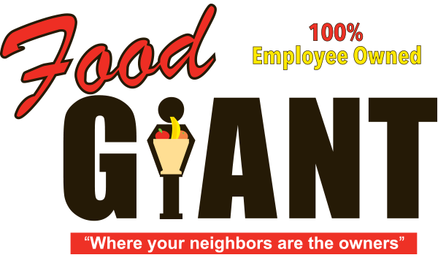

**COT 6931 Software Project Management Plan**



Food Giant Sales Flyer Generator



**Student Name: Kendrick Hagerman**

**Project Name:** Food Giant Sales Flyer Creator

**Client Name:** John Webb – Bay Minette Division Manager

**Client Phone Number:** 251-288-2964 (Company work cell)

**Client email:** johnwebb@foodgiant.com

**Professor:** Dr. Donna M. Lohr



# Introduction

This SPMP (Software Product Management Plan) is designed to describe the Food Giant Flyer Project, it’s expected deliverable and list all project milestones.

## Project Overview

Six division managers at Food Giant (a grocery chain) want a program for their store managers that will help them quickly create sale flyers based on items these store managers select. Food Giant already has global sale flyers but these are made and shipped from corporate. The division managers want the store managers to be able to quickly print custom flyers for perishable items they have excess stock in to help sell these items before they expire. This will help them to sell excess stock at a store and increase revenue.

The purpose of the project is to provide an easy to use program to the district and store managers of Food Giant that will allow them to create and design custom flyers using their inventory of store items that they can sent out to potential customers. This program will be hosted on a server and be distributed via the internet.

## Project Deliverables

* Project Definition – 02/19/2017
* Progress Report 1 – 02/26/2017
* Progress Report 2 – 03/26/2017
* Flyer Prototype Final – 04/11/2017
* Interim Report (signed by client) – 04/26/2017
* Interim Design Documents – 04/26/2017
* YouTube Presentation – 04/26/2017
* PowerPoint Presentation – 04/26/2017
* Final Product – 07/15/2017
* Final Product Documentation – 07/15/2017
* User Manual – 08/05/2017

## References

Project Definition - Hagerman_Kendrick_ProjectDefinition

Project Schedule - Hagerman_Kendrick_Schedule

Project Risk Mitigation Document - Hagerman_Kendrick_Risk_Mitigation

# Project organization

## Software Approach

I’m going to use a combination of the Agile and Adaptive Project Methodologies. I need Adaptive because my time for this project is fixed (until my capstone ends) and my costs (to host the website) will be fixed once I get that information from the stakeholder. I’m using Agile because I plan to separate each module’s (e.g. database, ASP.NET and C# GUI) development into separate sprints with a prototype to the stakeholder of this module’s functionality at the end of each sprint.

## Schedule

Please see Hagerman_Kendrick_Schedule for the latest version of the schedule.

## Risk Management

Please see Hagerman_Kendrick_Risk_Mitigation for the latest version of the risk management document.